**Innovision design documentation**

Team Innovision is here, and we have a goal for this semester. We currently have a videolab at the university, but the issue is that not everyone is familiar with how they can use the light equipment there. This is because it's unclear how to use the light equipment safely and correctly since there aren’t any manuals that properly instruct the users to use the lights. Our aim is to create user-friendly, clear manuals that are accessible to all. These guides begin by alerting readers to potential dangers before going on to explain how to safely operate the lights.

**Design/Style guidelines**

**Style for the PDF**

1. **Title font, size 26:** The Bold Font
2. **Paragraph font, size 12:** Montserrat
3. **Text alignment:** Justify

*Example of the three elements integrated*

title

‘’Lorem ipsum dolor sit amet, consectetur adipiscing elit, sed do eiusmod tempor incididunt ut labore et dolore magna aliqua. Pulvinar etiam non quam lacus suspendisse faucibus. Id donec ultrices tincidunt arcu. Tristique senectus et netus et malesuada fames. Sed id semper risus in. Cras adipiscing enim eu turpis egestas pretium aenean.’’

**Logo that will be used**

**Page numbering**

The pages will be numbered in the bottom middle.

**Visualization**  
It’s very good to show the visuals of the fonts along with the sizes of the font. Because of this, we’ve created a document that visualizes both factors. This is very important to see whether the fonts fit well together or not. A screenshot of the document with the agreed fonts will be shown down below. Here u could also see the page numbering and the justified text alignment.

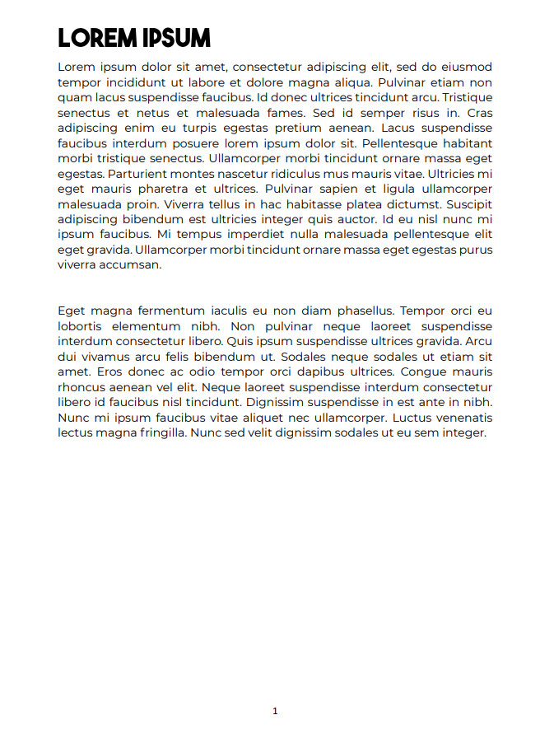

**The final manual**

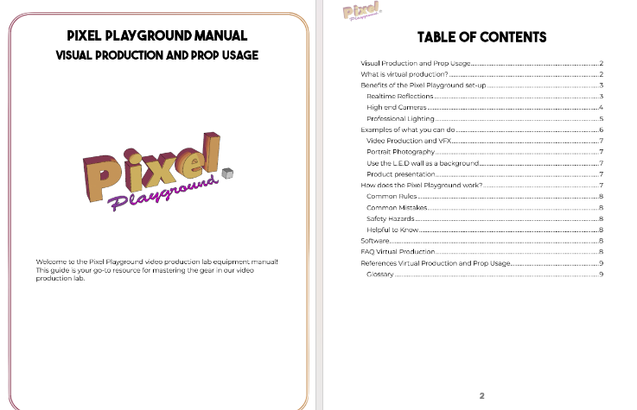

**Style for the Video**

1. **Text:** Montserrat + Dropshadows
2. **Video length:** Depends on the subject and how detailed u have to get with some components / user scenarios. (Some could be shorter and easier than others).
3. **Video renderfile:** H.264 (mp4)
4. **Video type:** Voiceover
5. **Framerate:** 30 FPS
6. **Transition:** Blur slide
7. **Background music:** Copyright free background music  
     
   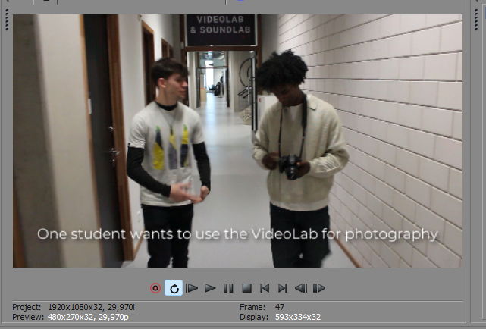

**Why do you use this form of prototype (paper/digital? Pros and cons?)**

We chose the **digital prototype** because when it’s done digitally, we could resolve our mistakes in a quicker way (which is a pro for digital prototyping) compared to creating the prototype on paper where you must start all over again time after time (a con for paper prototypes). Another example is that you’re able to work with the digital prototype from any location (a pro for digital prototyping) and that’s not the case with paper prototypes, because it forces people to be present in one room (a con for paper prototypes).

[Manuals equipment Pixel playground](https://git.fhict.nl/I477222/innovision/-/tree/main/Develop%20phase/Manual)

**What/who do you want to test?**

We want to assess the ease of understanding the online manual and identify ways to make it more user-friendly for students and teachers. Specifically, **we aim to determine if users can easily grasp how to use the equipment in the pixel playground and understand the best practices for its use**. Additionally, we seek to evaluate if the potential dangers associated with using the equipment are clearly communicated and if the instructional video is easy to follow without causing confusion.

**How to test your concept?**   
To see if our manuals is effective, **we want to let our focus group use our manual.** In order to see how effectively they can work with the lighting equipment at the end, will be determined by the project group. By letting our users learn how to use the equipment themselves instead of a teacher telling them how it works let’s our users have a better understanding of how each piece of the lighting equipment should work.

**Does the concept work?**

Although our university has a VideoLab, students are not familiar with how to operate the equipment. This could result in the breaking of pricey materials. To ensure that everyone is aware of the risks and uses the equipment with caution, **our concept idea is to create user-friendly manuals for our focus groups**, which include teachers and students, that they can refer to in the future.

**What’s your defined problem? Can your design solve the problem**? **How?**  
The problem we face is the difficulty in using the pixel playground and its equipment. **Our goal is to ensure that our designs are as user-friendly as possible, making it easy for students and teachers to understand.** To achieve this, we will create a PDF with short and long descriptions of each piece of equipment, along with a step-by-step guide on how to use them. Additionally, we will include information on the potential dangers and do's and don'ts associated with the equipment.

**How are the users perceiving the prototyping?**  
The users will be introduced to the prototype by scanning **a QR code** and then reading a comprehensive guide on their phone in a PDF. By doing this we can make QR code stickers which we can place on each piece of equipment with their corresponding QR code.

**Reflection:**

**What do you want to put in your next design iterations?**   
Our focus for the upcoming iteration is the design of a video that incorporates voiceover. To achieve this, we will be utilizing Sony Vegas for videos and FL Studio for audio. **Our aim is to create easy-to-understand concepts for each video** that comprehensively explain the features of the device and provide guidance on how to use it. These videos will be formatted as h.264 with a resolution of 1080p and a framerate of 30fps.

We will also modify our current work on the equipment based on the feedback received, to ensure better understanding and usability.

**What do you want to adapt?**   
Our final product must be sent to the website teams, and we aim to customize it to meet their specific delivery requirements. The process is straightforward, as it only requires clear communication between teams regarding the necessary adaptations and delivery instructions. For instance, Microsoft Teams could be used for this purpose.

**Which doubts do you still have?**  
We doubt that every single content group will have the exact same style because different people use different programs to edit audio and video. The built-in features of each program vary, and it's not certain if the other content group will adhere to the style guide rules or not.